Date. 30-05-2017

PRE-PRODUCTION QUESTIONNAIRE
FOR CHECKWEIGHERS

Note: F1 – Help for specific fields (after selecting the field press F1)
Fill in the colour fields Switch between fields using a mouse or TAB

Company | NIHVA Technologies Pvt Ltd
Address | NIHVA technologies Pvt. Ltd.  187, G-Block, Thermax chowk, MIDC  Chinchwad, Pune – 411019.
Contact person ( Sales department) |  | Pooja Badre | tel.  email | 7709586333  supportautomation@nihva.com
Contact person (technical department) |  | Mayur Derle | tel.  email | 7709209333  automation@nihva.com

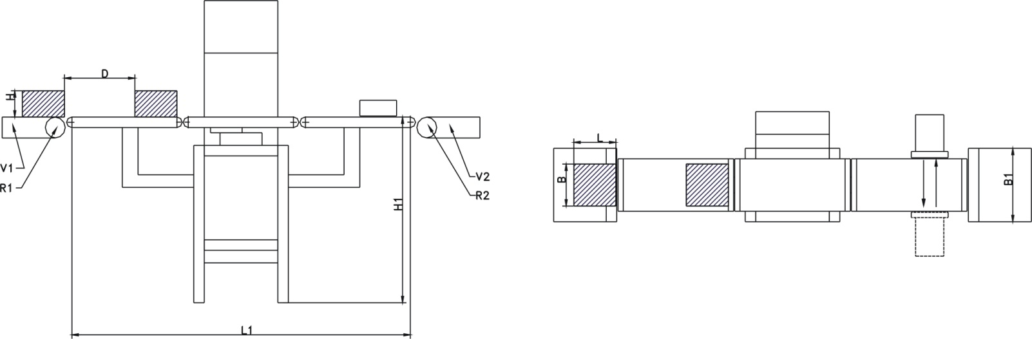
Operator

Dimensions

H1 – height of weighing platform +/- 50mm Default mm
L1 – place dedicated for scale Default mm
V1 – speed of conveyor before the scale Default
V2 – speed of conveyor behind the scale Default
B1 – belt width of existing conveyor Default mm
D – minimal distance between the goods Default mm
R1 – diameter of the roll Default mm
R2 – diameter of the roll Default mm

Product
Product orientation
Product transp. in regular gaps
Packaging
Form
Properties

Configuration
Required verification of the scale
Method of terminal mounting
Transport direction
Manufacturing of the scale
Req. resistance against environmental f.
Cleaning the scale

Conditions of operation

Vibrations
Air breeze
Environment
High/ low temp. of the environment Ambient°C

Devices/ additional functions

Discriminator
Discrimination of faulty goods

Warning tower lights
Sounder

Metal detector requires additional questionnaire
Sensor separating goods applicable only up to 25 items/minute
Sensor detecting line congestion applicable only if interfaced with PLC (details required)
Function of feedback to batcher
Function of I/O relay control

Interfaces

Communication port
Ethernet
USB

Comments
(Please submit additional requirements, that need to be fulfilled by the scale)

Description

Caution - Minimal and maximal mass, minimal and maximal packaging size are a prerequisite for processing the offer.
Product | Kind of Packaging | Open/ Closed | Length  L  In accordance with the drawing | Width  B  In accordance with the drawing | Height  H  In accordance with the drawing | Gross Mass | Weighing  Frequency | Expected Readability  (d)
Product | Kind of Packaging | Open/ Closed | [mm] | [mm] | [mm] | [g] | pcs./min | [g]
chilly powder | packet | closed | 200 | 150 | 70 | 1200 gms | 120 PPM

